April 2017 Year 2, Edition 4

Next Meeting: May 30, 2017

Detachment 1417 Board:

Commandant: Ric Ledford

Sr Vice: Bob Scar

Jr Vice: Don Chatham

Judge Advocate: Jack Albright

Past Commandant: Larry Thornton

Chaplain: Gene Ray

Paymaster: Don Alexander

Sergeant-at-Arms: Bradley Parker

Adjutant/Newsletter/Webmaster Phaedra Laushance

Detachment Email:
mcl.asheville@gmail.com

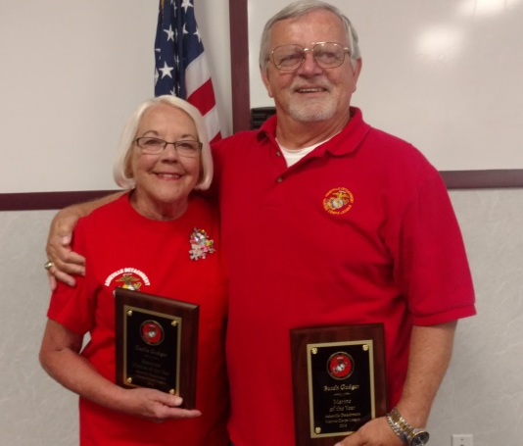

Congratulations to our 2017 Marine and Associate of the Year, Butch and Cecile Gudger!
Commandant’s corner

Marines and Associates,
One thing that is the cornerstone of any volunteer organization is teamwork to attain a specific goal. Our Marine Corps League is no different. It takes team work to make things happen.

One of the challenges of developing that teamwork is learning the different strengths of the team members. Additionally there is the challenge of differing personalities and ideas. Not everyone is the same nor are they motivated by the same things.

Veterans should know this more so than anybody having served with men and women from all different walks of life from all around the country. When a unit is given a mission it takes the whole team working together and employing their individual strengths toward one common goal.

You are part of an organization that is volunteer based and you still face similar challenges. Please remember when you are participating in a detachment event that some of the other members you will be working with may not think the same way that you do. What is important is that you remember that the goal we are striving for is bigger and more important.

Remember, WE are a team and our Marine veteran community needs our help.
Semper Fi
Commandant Ledford

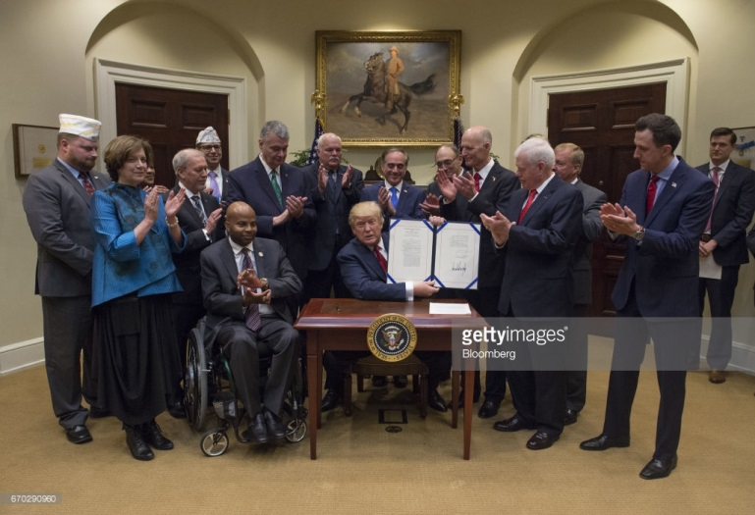
President Trump signing the temporary program to seek medical care in the private sector. (Getty Images photo)

President Donald Trump signed a bill on Wednesday April 19, 2017 to temporarily extend a program that lets some veterans seek medical care in the private sector, part of an effort by the president to deliver on a campaign promise.
The extension will give Veterans Affairs Secretary David Shulkin time to develop a more comprehensive plan to allow veterans to more easily go outside the VA health system for care. Under the bill Trump signed into law, the VA will be allowed to continue operating its Choice Program until the funding runs out, which is expected early next year. The program was scheduled to expire on Aug. 7 with nearly $1 billion left over.
Trump said veterans have "not been taken care of properly" and that the program will continue to be able to see "the doctor of their choice."
"You got it? The doctor of their choice," he repeated for emphasis.
Shulkin, who attended the bill signing, has said the money is needed to pay for stopgap services while he works on the longer-term plan. He said Wednesday that the plan is due in the fall. Congress would have to approve any changes to the VA health system.
Shulkin said the extension is important because it gives veterans another avenue for care.
"It's this approach where veterans can get care wherever they need it that really is the way that we're going to address all the needs and honor our commitments to our veterans," he said after Trump signed the bill.
The Choice Program was put in place after a 2014 scandal in which as many as 40 veterans died while waiting months to be scheduled for appointments at the Phoenix VA medical center.
The program is intended to provide more timely care by allowing veterans to go outside the VA network only in cases where they had to wait more than 30 days for an appointment or drive more than 40 miles to a facility. Yet the program itself often encountered long wait times of its own.
The new law also calls for changes to alleviate some problems by speeding up VA payments and promoting greater sharing of medical records.
Major veterans' organizations and Democrats support a temporary extension of the Choice Program, but are closely watching the coming VA revamp of the program for signs that the Trump administration may seek greater privatization. Those groups generally oppose privatization as a threat to the viability of VA medical centers.
Trump had pledged during the presidential campaign to give veterans freedom to seek care "at a private service provider of their own choice."
Mark Lucas, executive director of Concerned Veterans for America, commended Trump for upholding a campaign promise to make veterans a priority, but said more needed to be done. Lucas said the Choice Program was a well-intentioned "quick fix" to the Phoenix scandal, but that it remains flawed and has forced too many veterans to seek care at what he termed failing VA facilities.
"Congress now has some time to work with Secretary Shulkin on broader, more permanent choice reforms that will truly put the veteran at the center of their health care and remove VA bureaucrats as the middlemen," Lucas said. "We look forward to supporting legislation that will let veterans go outside the VA for care when they want or need to."
Sen. John McCain, R-Ariz., said more than 1 million veterans have made 7 million appointments with health care providers in their communities under the Choice Program. He said those appointments would have otherwise "lagged" in the VA scheduling system.
More than 1 million out of 9 million veterans in the VA system use some Choice care, with agency data pointing to even greater use this year.
McCain, a Navy veteran, said the extension "sends an important message that we will not send our veterans back to the status quo of unending wait-times for appointments and substandard care." He said more work is needed, but called the legislation "an important first step."
Shulkin has said he would like to expand veterans' access to private care by eliminating the Choice Program's current 30-day, 40-mile restrictions. At the same time, he wants the VA to work in partnership by handling all the scheduling and "customer service," something that congressional auditors say could be unwieldy and expensive.

⌂⌂⌂⌂⌂⌂⌂⌂⌂⌂⌂⌂⌂⌂⌂⌂⌂⌂⌂⌂⌂⌂⌂⌂⌂⌂⌂⌂⌂⌂⌂⌂⌂⌂

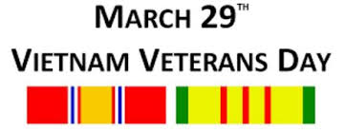

President Trump signs law declaring National Vietnam War Veterans Day
By: Mackenzie Wolf, March 29, 2017 (Photo Credit: Reynaldo Leal/VA)
An act of Congress honoring Vietnam veterans with a day of recognition was signed into law by President Trump on Tuesday, per a White House press release. March 29 is now designated as National Vietnam War Veterans Day by the Vietnam War Veterans Recognition Act of 2017 according to Gateway Pundit. The U.S. flag is to be flown in commemoration of those who served in Vietnam.
The bipartisan bill was sponsored by Sen. Pat Toomey, R-Pa., and Sen. Joe Donnelly, D-Ind. The bill passed the Senate last month and the House last week.
Forty-four years have passed since the last U.S. troops withdrew from Vietnam. Due to the unpopularity of the war, veterans returning home were often met with disdain and did not receive support or gratitude for their service.
“Some of them were actually treated quite poorly,” Toomey said. “And that was a tragic period in our history driven by people’s perceptions of the war. Fortunately, that, I think, is behind us now. And I hope and I believe we’ve gotten to a place where the American people realize how much we really should be grateful to the men and the women who served this country in Vietnam during that very, very difficult time.”
Out of the 2.7 million U.S. service members who served in Vietnam, more than 58,000 were killed and more than 304,000 were wounded. An estimate by the Smithsonian suggests that approximately 271,000 Vietnam veterans may have post-traumatic stress disorder (PTSD).
Previously, a proclamation by President Obama declared March 29, 2012, Vietnam Veterans Day. With the Vietnam War Veterans Recognition Act of 2017 signed into law, Vietnam veterans will be commemorated annually for their service.

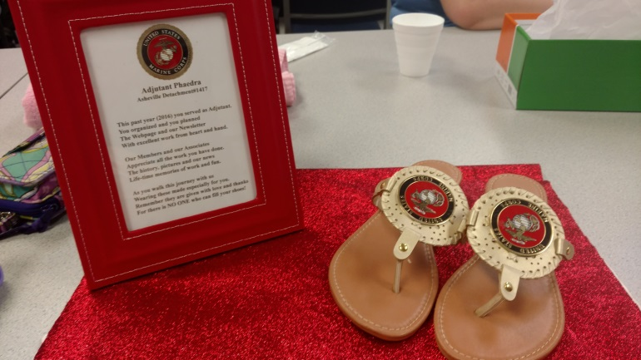

I would personally like to thank everyone for this very generous gift!
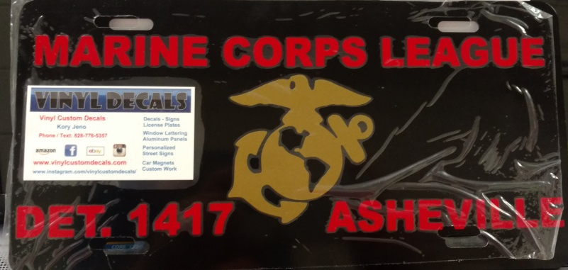
Would you be interested in one of these??? Contact John Dies at jakeusmc84@gmail.com for more information!

Newsletter Competition 2017
It’s that time of year that we need to submit three different newsletters to be judged on the national level.
What we need to know, which one stood out to you the most? Which one would you like to see again? Which was the best of the last year?
Detachment Newsletters need to be sent in by early June, so don’t hesitate to let Phaedra know!
do you know these individuals?
Robert Putnam - Asheville
Ian Zepp - Arden
Robert Parker - Mills River
Frank Fazio - Hendersonville

These are marines at large (MALs), and we are looking to bringing them in to the mcl! Let Don chatham, Ric Ledford, or Larry thornton know any information to help us raise our recruitment numbers! Thanks!
Monthly Dinners:
(All dinners begin at 1800 (6pm) unless otherwise noted.

May 9th: Tommy's, 247 N. Main St, Weaverville
June 13th: El Chapala, 282 Smokey Park Highway, Asheville
July 11th: Wild Wings Cafe, 65 Long Shoals Rd, Asheville
August 8th: Annual Picnic at the Fireman’s Camp, Clayton Rd, Arden
September 12th: Apollo Flame Bistro, 1025 Brevard Rd #1, Asheville
October 10th: Stone Ridge Tavern, 1003 Brevard Road, Asheville
November 10th: Marine Corps Ball
December 6th: O'Charley's—Detachment Christmas Party.

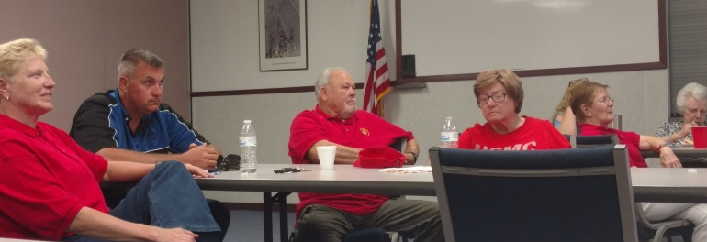

Everyone listening and enjoying the April potluck!

Proof that Don Alexander works!
This Month's History Lesson, the Marine Corps Way: May
1 May 1992: | BGen Marvin Hopgood Jr. led 1,500 Marines from Camp Pendleton to help quell the Los Angeles riots.
2 May 1946: | Marines helped quell a prison riot at Alcatraz Island, California.
3 May 1898: | Lt Dion Williams and Marines from the USS Baltimore raised the American flag over Cavite, Philippines.
4 May 1942: | Marines participated in the Battle of the Coral Sea during WW II.
5 May 1919: | HQMC moved into the new Navy Building on Constitution Avenue in Washington, DC.
5 May 1961: | Marine pilots retrieved America's first astronaut, Navy Commander Alan Shepard.
6 May 1937: | Marines at NAS, Lakehurst, New Jersey, helped rescue survivors of the Hindenburg disaster.
6 May 1942: | The colors of the 4th Marines Regiment were burned to avoid capture on Corregidor.
7 May 1942: | The 8th Defense Battalion (reinforced) landed on Wallis Island from Tutuila Island.
8 May 1808: | Marine Barracks, Charleston was established under Lt Pinckney and 22 Marines.
9 May 1846: | Lt Archibald Gillespie delivered a presidential message to Capt John C. J. Fremont in Oregon.
10 May 1845: | Marines and Sailors of the USS Constitution landed at Tourane, Cochin China (later known as Da Nang, Vietnam).
10 May 1934: | The first amphibious landing exercise by embryo FMF at Culebra.
11 May 1920: | The 16th Marine Regiment organized at Philadelphia for duty in Cuba, Haiti and the Dominican Republic.
12 May 1975: | Marines were alerted for rescue of the Mayaguez crew and assault on Koh Tang Island, Cambodia.
13 May 1846: | Was was declared against Mexico.
13 May 1928: | Marines participated in the Battle of Cua River in Nicaragua.
14 May 1917: | The first Marine detachment transferred from Annapolis to a new Marine post at Quantico.
14 May 1919: | Marines from the USS Arizona landed at Constantinople to secure the American Consulate.
15 May 1862: | Corporal John Mackie became the first Marine awarded the Medal of Honor.
15 May 1991: | After flooding killed 130,000 in Bangladesh, the 5th MEB provided aid in Operation Sea Angel.
16 May 1927: | Marines participated in the Battle of La Paz Centro in Nicaragua.
17 May 1962: | The 3rd MEU landed in Thailand, easing communist pressure.
18 May 1902: | Marines from the USS Ranger landed in Panama City to protect Americans.
19 May 1927: | The 11th Marine Regiment arrived at Esteli, Nicaragua, for garrison duty.
20 May 1803: | Marines participated in the raid on Tripoli.
20 May 1906: | Major John A. Lejeune embarked his battalion for duty in Panama.
21 May 1846: | A Marine regiment formed for duty with General Winfield Scott's Army in Mexico.
22 May 1912: | Lieutenant Alfred A. Cunningham became the first Marine officer assigned to aviation duty.
23 May 1899: | Marines arrived to secure Cavite Naval Base, Philippines.
24 May 1900: | Marines landed at Taku, China, to establish Legation Guard at Peking.
26 May 1853: | Major Jacob Zeilin (in charge of Marines) arrived with Commodore Matthew C. Perry's squadron at Okinawa.
27 May 1803: | Marines aboard the USS John Adams engaged Tripolitan gunboats off Tripoli.
28 May 1945: | The 5th Marine Regiment began the final assault against Shuri Castle, Okinawa.
29 May 1944: | The 4thMarDiv sailed from Pearl Harbor for Saipan Operation.
30 May 1873: | 68 Marines from USS Ohio and USS Powhatan restored order after a fire in Boston.
31 May 1900: | Marines guarded the Peking Diplomatic Quarters during the Boxer Rebellion.

Information courtesy of:
http://www.muddyboots.net/semperfi/history/hist_05.html

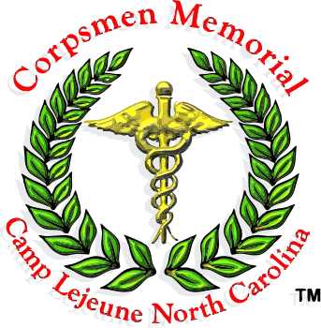
Do you know a FMF Corpsman that should have a memorial? The following website has more information!
http://fmfcmf.org/
∞∞∞∞∞∞∞∞∞∞∞∞
Do you know someone would enjoy being involved with the Detachment happenings? Are they a Marine or FMF Corpsman? If so, let Don Chatham know, and he will get some information sent! Or…direct them to our website! And don’t forget to grab some cards from Phil Swartz to hand out to potential members!

Our website address is:
www.ashevillemcl.org

≈≈≈≈≈≈≈≈≈≈
Are you on Facebook? Join us on our Facebook page at https://www.facebook.com/marinecorpsleagueasheville/

Commandant Ric Ledford handing out the Member of the Year award to Butch Gudger! Getting hugs from Cecile Gudger for the Associate of the Year!
One of our staple associates! Cynthia Ray!

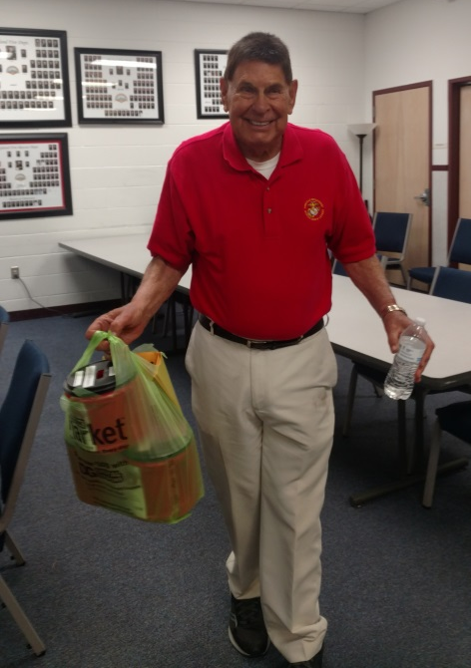
Chaplain Gene Ray always with a smile and a prayer for anyone!

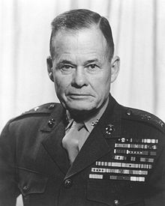

"Good night, Chesty, wherever you are!”

